Comprehensive Financial Management System
(CFMS)
DDO Data Capturing Process

Contents
Contents 2
1.Document Summary 3
2. How the Data is Captured? 3
3. How to access the application? 4
4. Login 4
5. DDO Data Entry 7
5.1 DDO Selection 7
5.2 Hierarchy 8
5.3 Cadre Strength 10
5.4 Assign Employees 12
5.5 Create Sections 16
5.6 Assigning Posts to Sections 18
5.7 Leave Approval Hierarchy 19
5.8 Loan Approval Hierarchy 21

1.Document Summary
This document entails the steps to be followed by the DDOs to capture the entire data of the employees with respect to the departments. It includes Hierarchy, Cadre strength, Assign employees, Create sections, Assign posts to sections, Leave approval hierarchy & Loans approval hierarchy.

2. How the Data is Captured?

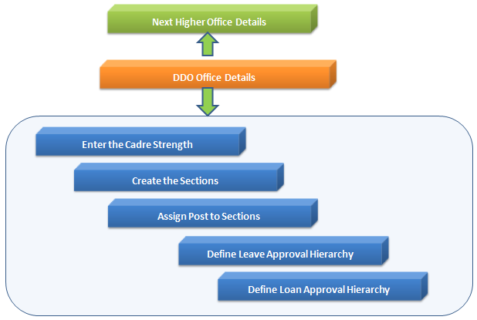

3. How to access the application?
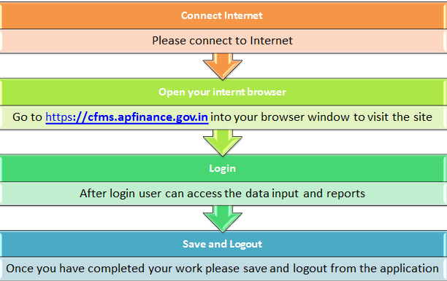

4. Login
Step 1: Enter the CFMS Portal URL https://cfms.apfinance.gov.in in IE (Internet Explorer version 8, 9 and 10) or Mozilla or Google chrome browser.
Step 2: Click on ‘Enter’ button on your keyboard to navigate to CFMS Portal login page.
You can access all the portal applications by getting logged in to CFMS portal.
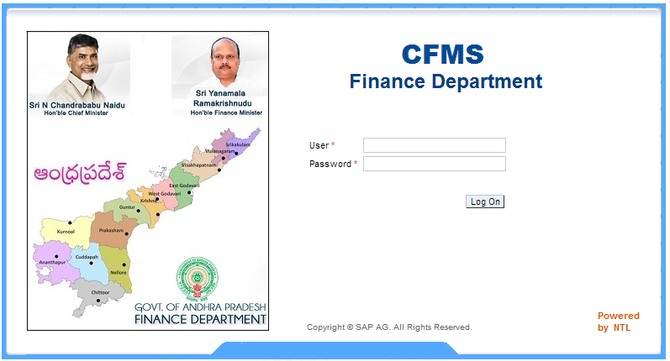
Below listed are the First time ‘login instructions’ to the end user:
- On the ‘Login screen’, enter your existing ‘User id’ used for accessing CFMS Portal system.
- Enter the ‘Password’ which has been provided by the administrator through communication mail.
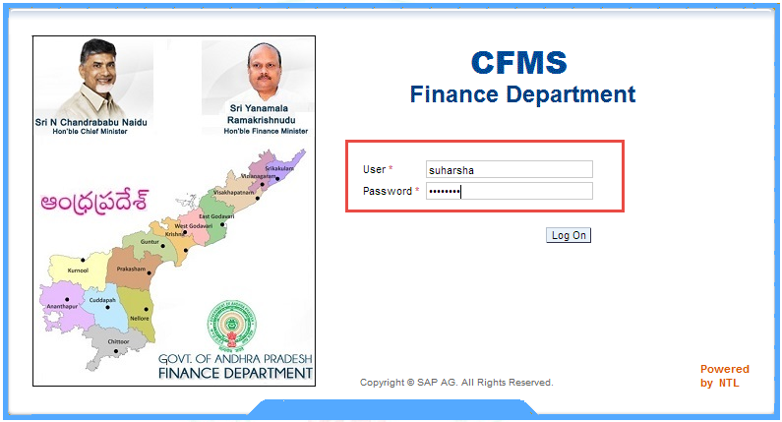
- Click on the ‘Logon’ button.
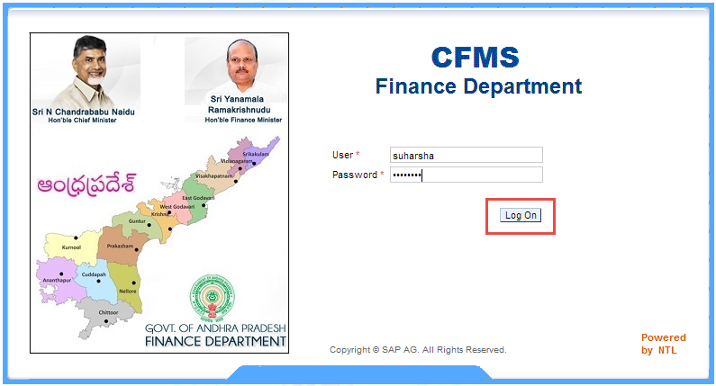

- Below shown screen will be displayed (only if the user is getting logged onto the portal for the first time, as this helps the user to change his/her password). Enter the ‘Old password’ provided to you by the administrator.
- Enter the ‘New password’ and confirm the password by re-entering it in ‘Confirm password’ field.
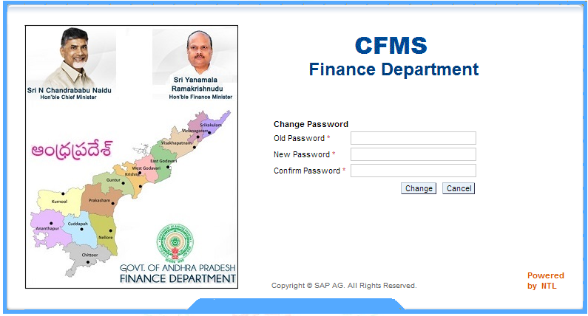
- Click on the ‘Change password’ button.
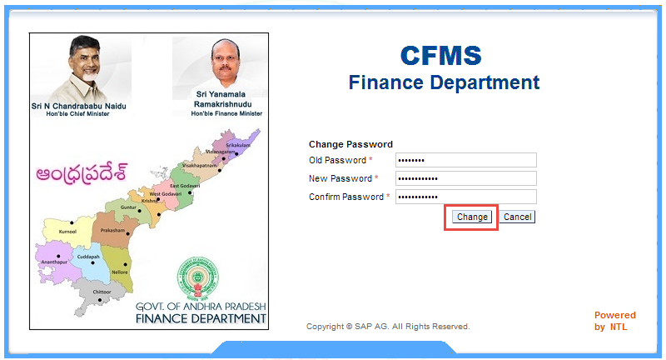
Now, you will be navigated to CFMS portal main page.

5. DDO Data Entry
Below listed are the steps to be followed by the DDOs to capture the data.
Step 1: Click on the DDO Data entry tab.
You will be navigated to the below shown screen.
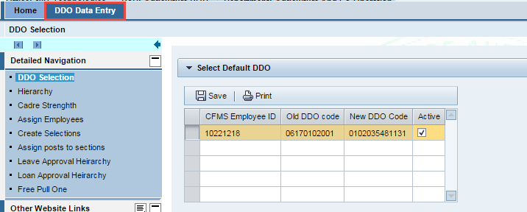

5.1 DDO Selection
Step 1: On the left side of the screen, click on DDO Selection. You will find a default screen as shown below. It displays the details like CFMS Employee ID, Old DDO code, New DDO code of the DDO who has been logged in. it also displays the status of the DDO whether he / she is Active or Inactive.
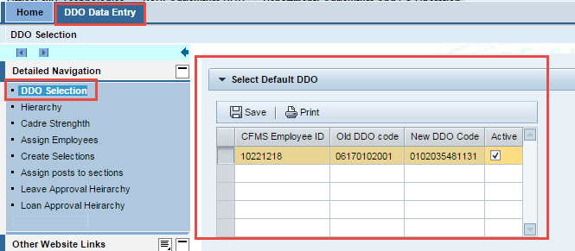

5.2 Hierarchy
Here all the details regarding the office hierarchy are to be entered. Below listed are the steps to be followed for your reference.
Step 1: Navigate to DDO Data Entry → Hierarchy.
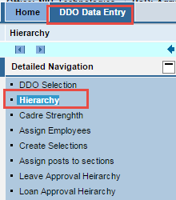
You will be navigated to the below shown screen.
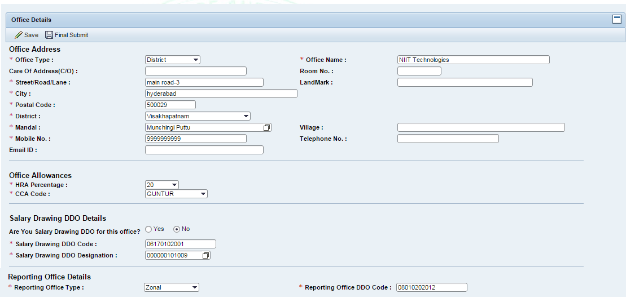
Step 2: Enter all the mandatory details.
Note: All the fields which are marked with an astriel (*) are mandatory.
In the section Salary Drawing DDO Details you can see a field Are you Salary drawing DDO for this office? with two options Yes & No.
If the option YES is selected ,by default the salary drawing DDO code & designation will be displayed.
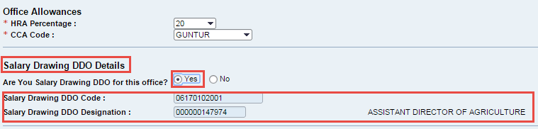
If the option NO is selected, you need to enter the Salary Drawing DDO code and select the Salary Drawing DDO Designation.
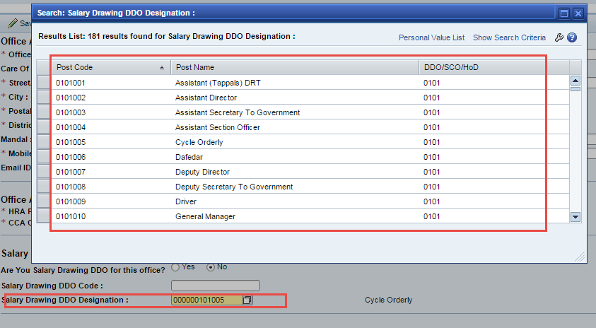
Step 3: Click on Save button to save the details and click on the Final Submit button to submit.

Note! Once the details are submitted, no further changes can be made (ie Hierarchy, Cadre strength, Assign employees, Create sections, Assigning posts to sections, Leave approval hierarchy, loan approval hierarchy).

5.3 Cadre Strength
The employee needs to check all the available posts with respect to his / her office. In case of unavailability of any of the offices, the employee needs to add the offices by clicking on Add New job button. He / She have to fill all the sanctioned strength for all the available posts.
Step 1: Navigate to DDO Data Entry → Cadre strength
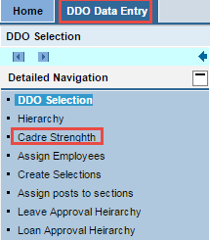
Step 2: Click on the Get Details button.
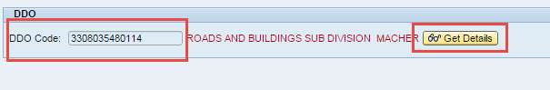
All the designations (Vacant / Non vacant positions) falling under the respective DDO will be displayed.
Step 3: Enter the Sanctioned Strength.
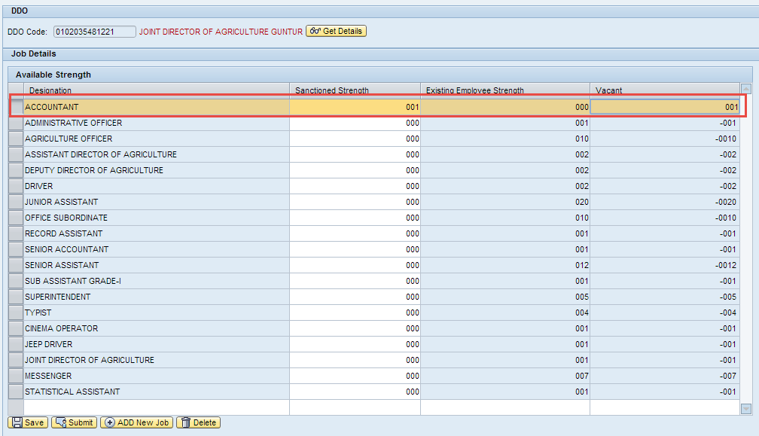
Depending on the sanctioned strength, the vacant position will be displayed.
Step 4: Click on the Save button to save the details.
Adding a New job
Step 1: Click on Add new job button.
Step 2: Enter the details of the job in the respective fields and click on the Save button.
Step 3: Click on Submit to submit the details.
The submitted details will be appeared in the available strength as shown below.

5.4 Assign Employees
He / She has to view all the available employee details and if any of the employees found not belonging to the respective office, that particular employee has to be selected and released by following the below listed steps.
Step 1: Navigate to DDO Data Entry → Assign Employees.
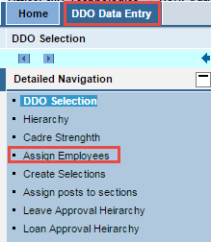
You will be navigated to the below shown screen.
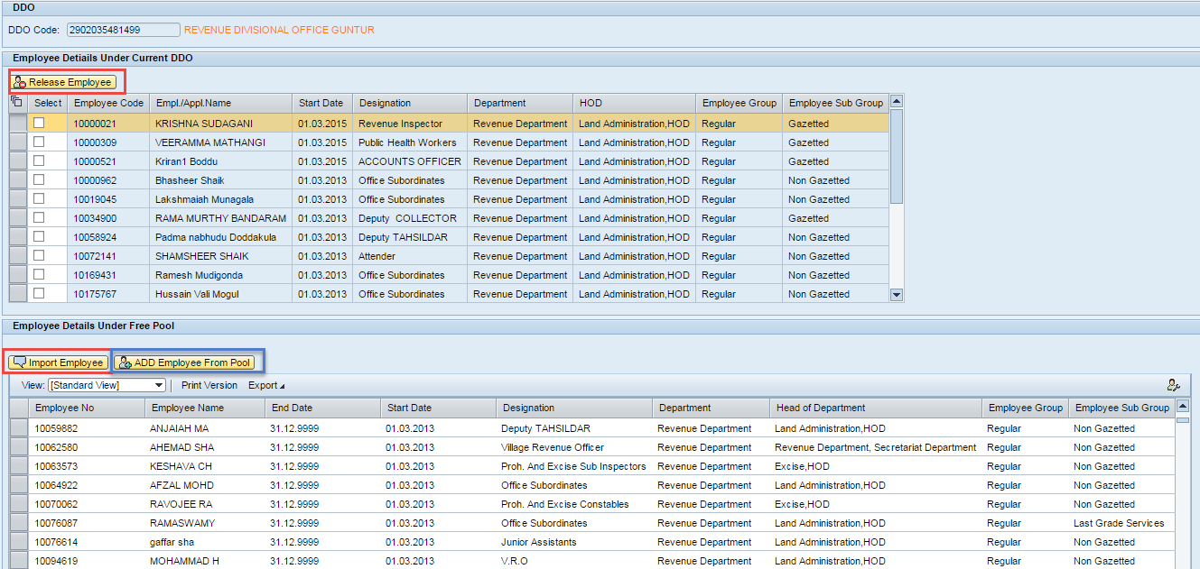

Adding employee from Free pool to current DDO.
Step 1: Select the employee and clcik on Add employee from pool button.
Step 2: Enter the required fields & click on Add to Me button.
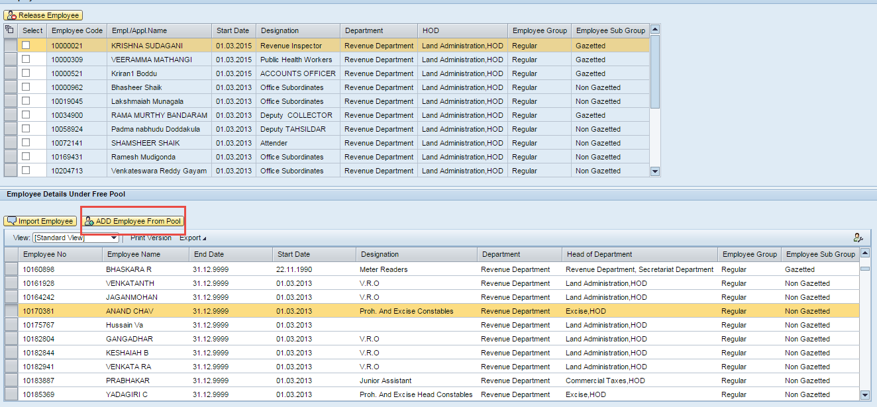
Releasing an Employee from the current DDO
Step 1: Select the employee and click on Release employee button.
The released employee details will be displayed in the Free pool.
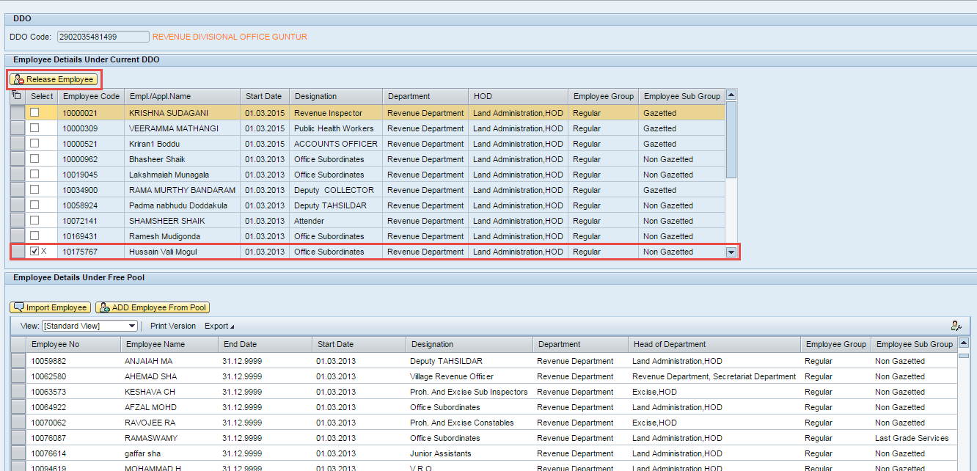
Import employee
In cases if the employee is not available in free pool, the DDO has to import the employee by following the below steps.
Step 1: Click on Import employee button , to request for an employee who has to be added under the respective DDO by entering all the required fields.
Note : This action is to be performed only when the employee is not found in both the pools i.e free pool, employees under the current DDO.
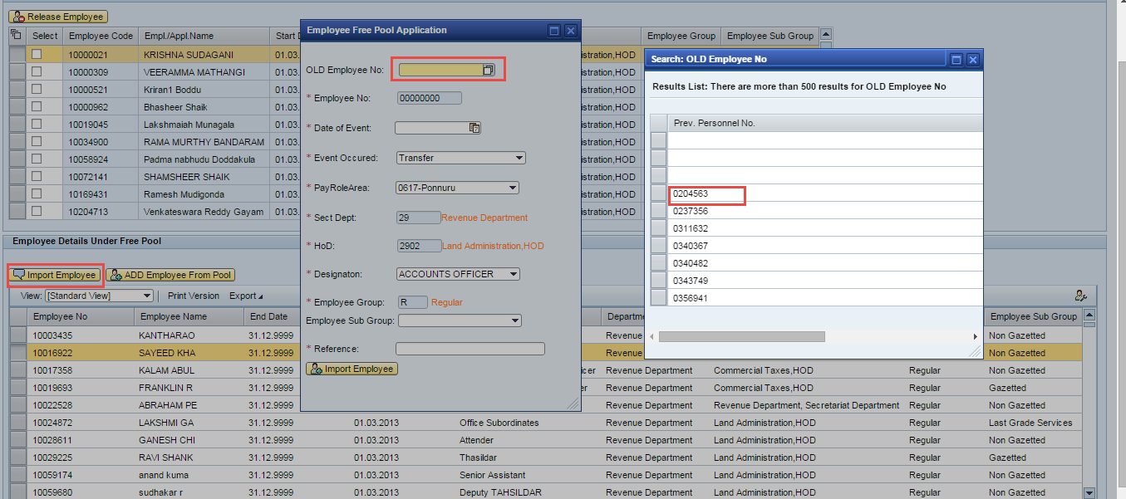
Step 2: Once done with entering the details, Click on Import employee button.
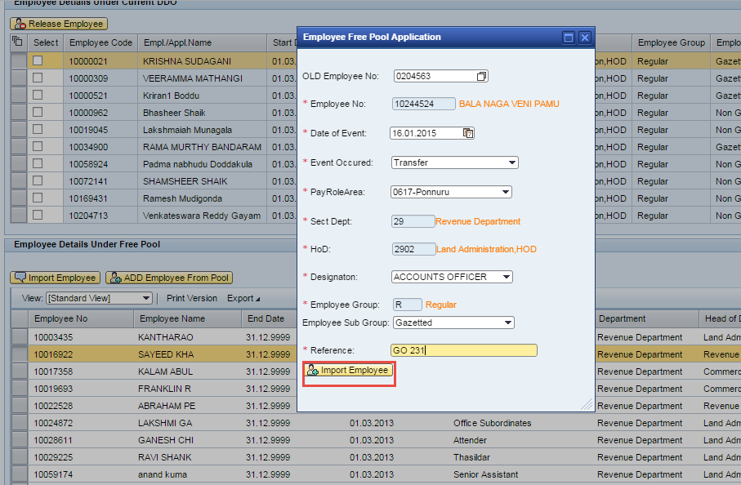
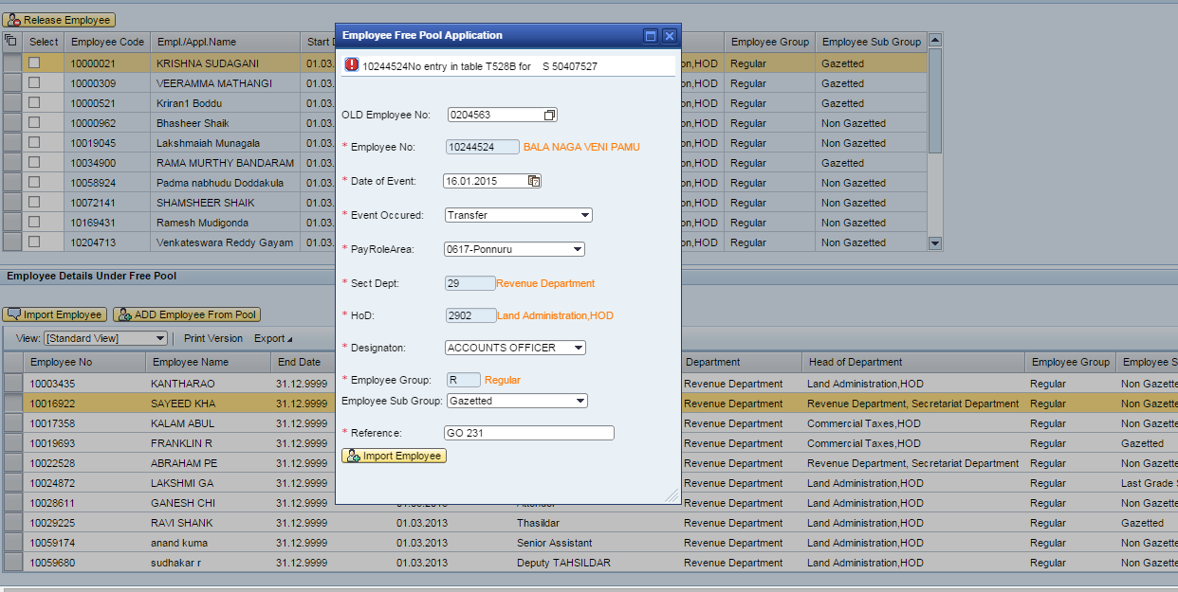

5.5 Create Sections
He / She have to create all the available sections in the office.
Step 1: Navigate to DDO Data Entry → Create Sections.
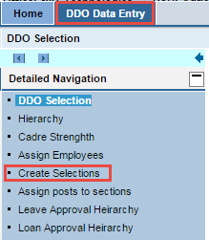
You will be navigated to the below shown screen.
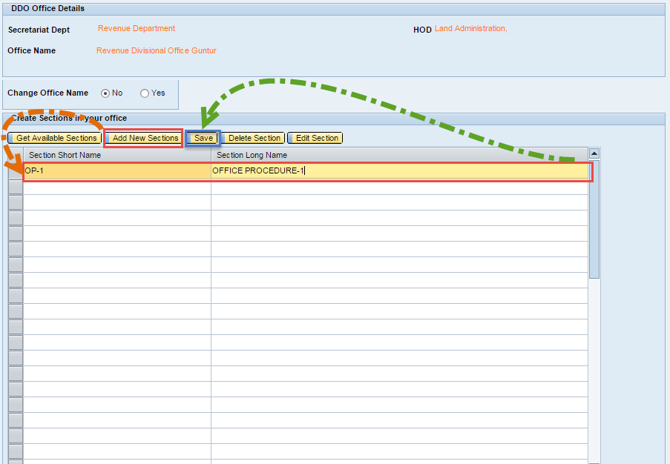
In the above screen the DDO can view all the available sections, Add a new section, Delete a section & Edit a section.
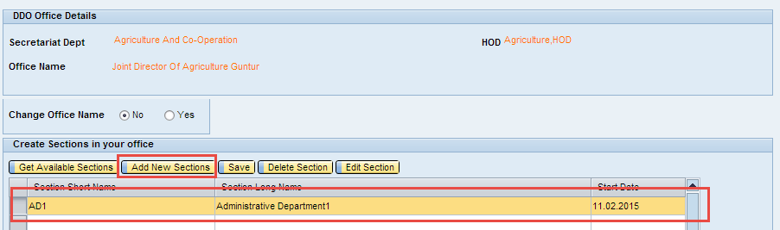
Step 2: Click on Add new sections.Enter the Section short name , Section Long name and Start Date.
Step 3: Click on Save button to save the created section.
The section created will be displayed in the available sections as shown below.
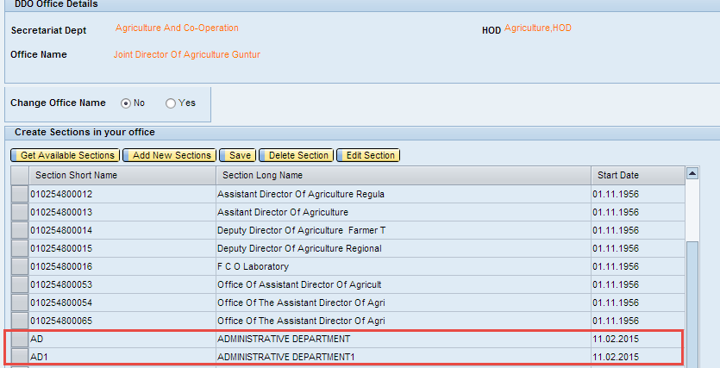
Editing a Section
Step 1: Select the department and click on the Edit section.
Step 2: Make necessary changes and click on the OK button.
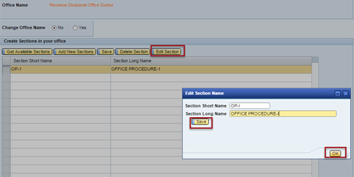
Deleting a Section
Step 1: Select the section and click on the Delete Section button.

5.6 Assigning Posts to Sections
All the sections which are created earlier by the DDO should be assigned to posts. Below listed are the steps to be followed.
Step 1: Navigate to DDO Data Entry → Arrange posts to sections.
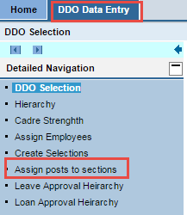
You will be navigated to the below shown screen.
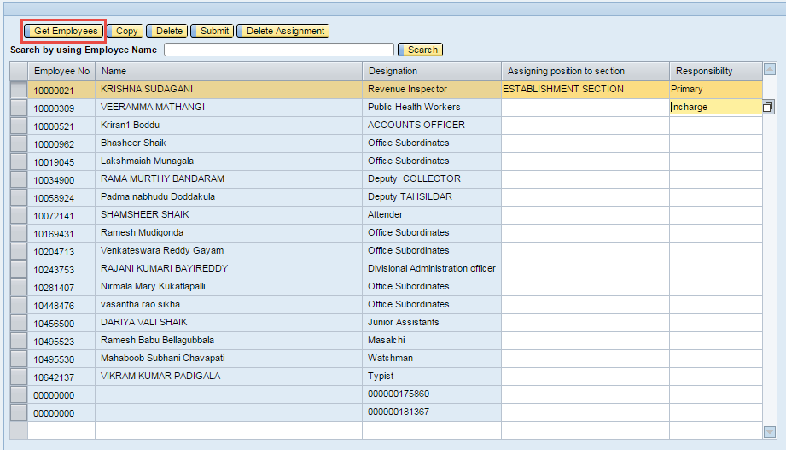
Step 2: Click on Get Employees button to view the details of all the employees.
Step 3: Select the position & responsibility to be assigned to the employee from ‘Assigning position to section’ & ‘Responsibility’ options.
Step 4: Click on the Submit button to submit the details.
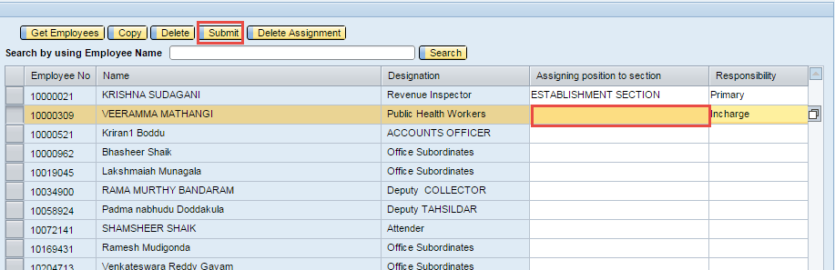
Deleting an employee
Step 1: Select the employee & click on the delete button.
Copying employee details
Step 1: Select the employee and clcik on the Copy button to copy the details.
Delete Assignment
Step 1: Select the employee and click on Delete Assignment button to delete the position/post allocated for respective employee.

5.7 Leave Approval Hierarchy
The Leave approval hierarchy for all the employees with respect to all the leave types is to be filled.
Step 1: Navigate to DDO Data Entry → Leave approval hierarchy.
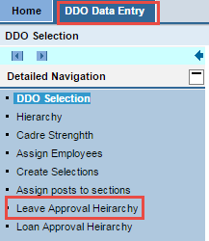
You will be navigated to the below shown screen.
Step 2: Select the section and click on Get employees button .
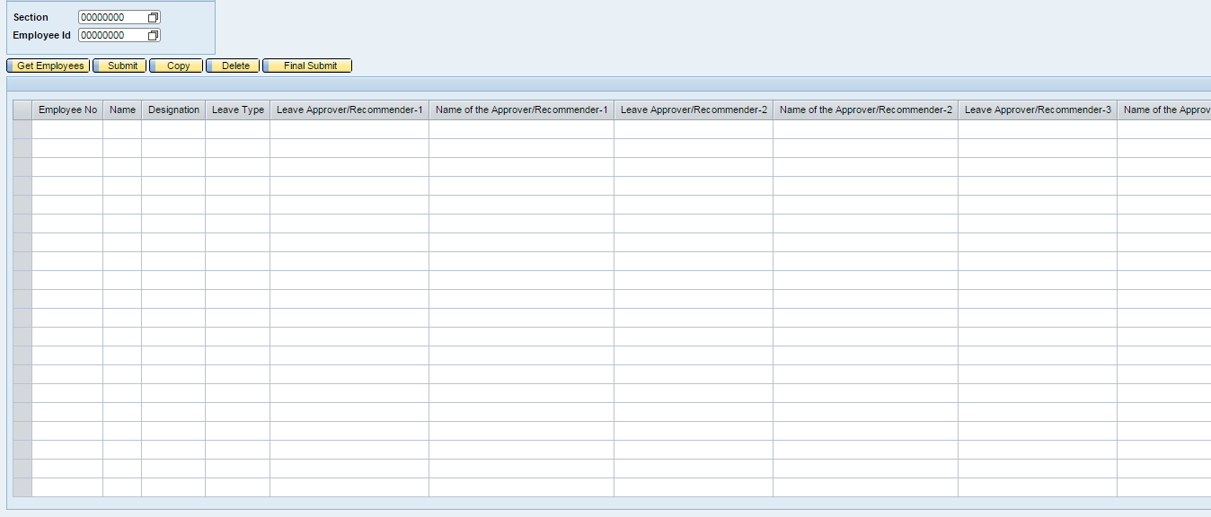
All the employees related to the respective section will be dispalyed.
Step 3: Select the Leave type, Leave approver1, Leave approver 2(if applicable) etc. and click on the Submit button to submit the details.
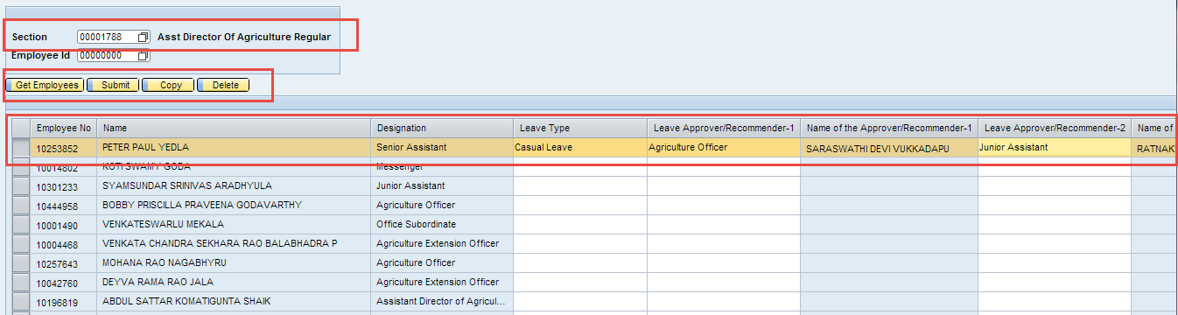
Copying employee details.
Step 1: Select the employee and click on the Copy button to copy the details.

5.8 Loan Approval Hierarchy
The Loan approval hierarchy for all the employees with respect to all the loan types is to be filled.
Step 1: Navigate to DDO Data Entry → Loans approval hierarchy.
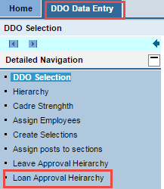
You will be navigated to the below shown screen.
Step 2: Select the Section and Click on Get Employees button.
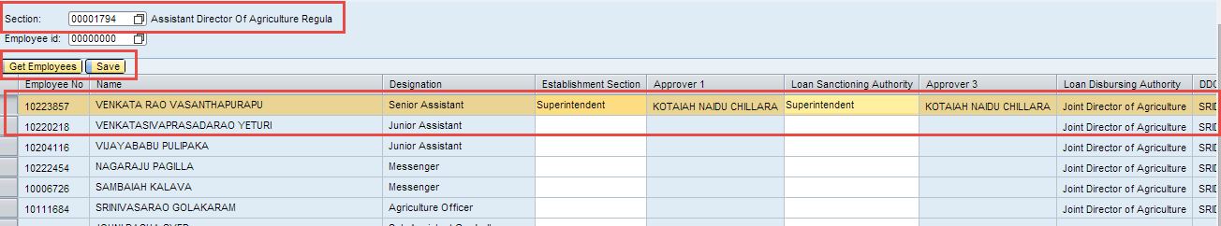
All the details of the employees will be displayed.
Step 3: Select the establishment sanction, approver1, loan sanctioning authority etc and click on Save button.

